EBP

Access & Appraise:

Evaluating Information and Evidence
for
Quality and Relevance

Guided Search and JTASS Evaluation Lab
Guided Search and JTASS Evaluation
The Quick Evaluation of Results from a Search of the Biomedical Literature for Quality and Relevance

Introduction:

The JTASS evaluation uses five key characteristics of a biomedical citation to determine if an article is of high quality, relevant and applicable to a specific, patient oriented clinical question. Electronic databases contain links to data fields such as the journal, title key words, author, site or location where the study was performed as well as the location of contributing authors, and access to the summary or article abstract. These characteristics are known through the acronym “JTASS,” standing for Journal, Title, Authors, Site where the study was performed and Summary (Abstract key aspects).
A JTASS evaluation, a classic, quick evaluation method developed before electronic databases were readily available, uses characteristics of a literature citation that are “indexed” or used as identifiers to categorize a citation or article. (These same characteristics can be used to evaluate the citation or article without the attributes of an electronic database. However, finding the information is a little more difficult without the links in an electronic database.)

Using the JTASS method, a reader can quickly evaluate the value of a citation in a few minutes, especially if the citation is in an electronic database where active links provide information about the Journal, Title, Authors, Site and Summary This allows a reader to be selective in accessing and reading the full text of a citation. If the JTASS evaluation indicates the citation is for a high quality, highly relevant article, the reader knows he or she should go forward. If the JTASS indicates the citation is not high quality or not relevant to the particular patient, the reader should skip the article for the time being. Thus, the JTASS method helps the clinician searching for high quality, relevant evidence quickly and efficiently make a decision whether or not to access and read a particular result from a search of the biomedical literature.

Practice makes perfect. After a few JTASS evaluations using the detailed JTASS Guide, the clinician will be able to evaluate a citation in a few minutes, saving hours of reading “not quite relevant” or “not what I needed” literature.

Instructions:

NOTE: For this example and lab activity, use the following patient scenario, PICO format question and key search words. For other searches in the future, substitute search terms and limits with your PICO component terms.

- Follow the search directions in sections A through E to perform a guided search and access a specific citation and abstract.
Weinstein JN, Tosteson TD, Lurie JD, Tosteson AN, Hanscom B, Skinner JS, Abdu WA, Hilibrand AS, Boden SD, Deyo RA. Surgical vs nonoperative treatment for lumbar disk herniation: the Spine Patient Outcomes Research Trial (SPORT): a randomized trial. JAMA 2006 Nov 22;296(20):2441-5.
- Enter information, notes and results in the Search Strategy Evaluation and Selection Rationale (JTASS) form which follows the lab instructions as you follow the search directions.
- The Search Strategy Evaluation and Selection Rationale (JTASS) form follows the lab instructions.
- Download an electronic copy of the Search Strategy Evaluation and Selection Rationale (JTASS) form from CygNET (Unit 4 Lab).
- Save the file on your hard drive before using. Modify the file name to save for future reference. (e.g., using JTASSGuidedSearch.topic.name.date.
- Type and paste information into the Search Strategy Evaluation and Selection Rationale (JTASS) form.
- The guided search will lead you through a search to a specific article. Follow the instructions to evaluate the quality and relevance of the article using the JTASS Guide and filling in the JTASS form.
- Access the full abstract and citation through the electronic database (PubMed) in order to use the database indexed fields and links to find the information required to evaluate a citation using the JTASS method. (Using the abstract view while in the database is efficient.)
- Turn in the Search Strategy Evaluation and Selection Rationale form with notes from the guided search.
- the RSS link and the Abstract static link (URL to the abstract) must work when clicked on. (You may need to add a space after pasting the link into the Search Strategy Evaluation and Selection Rationale form.)
- The bibliographic citation must be formatted in the Vancouver style. See the Vancouver Style Guide in Resources.
- Save the completed file. RSS links and links to the abstract will continue to work when the file is opened again. The RSS link is a great way to save and automatically update a search with new articles.
Guided Search and JTASS Lab Activity
The Quick Evaluation of Results from a Search of the Biomedical Literature

Patient Scenario

James, 32 year old male, technical sales manager who drives long distances (or at least for long periods of time) and is a frequent flier for his job, has been visiting you for neck and back issues for over two years on a fairly regular basis. In addition to working from the car and plane, he has a home office and uses a laptop. You and he have discussed work place ergonomics as well as exercise and stretching to alleviate chronic neck and back pain.

On a recent visit, he tells you he heard on the TV news that chronic back and neck pain causes depression -- or was it vice versa? -- and that chiropractic and alternative care that relieves the pain can relieve depression. He asks, “Do you think that this back and neck thing could be causing me to feel blue lately? Or do you think mid-winter blues are causing this pain in my lower back and neck? My colleague just had lumbar disk surgery and feels great. I’m not so excited about surgery. Should we be doing something different?”

He says after hearing that news report, he’s been looking on the internet to see what might help with the chronic pain and lift his mood.

 | Patient, population, problem | Intervention | Comparison | Outcome
Consider | 32 yo WM  chronic neck pain / chronic back pain  spine  lumbar disk | CAM therapy chiropractic acupuncture  “physical therapy” nonsurgical nonoperative botanical  herbal  massage | Prescription drugs  Opioid compounds  surgery  massage…  alternative therapy treatment | treat / relieve  (chronic) neck / back pain  spine conditions / injuries  (mild) depression
Question(s) | For [P= adult patients with chronic (neck / back / spine / lumbar) pain / specific diagnosis], is [I= conservative / nonoperative treatment / botanical therapy / acupuncture] as effective as [C= surgery] to [O= alleviate pain / treat symptoms of mild depression]?

Search Strategy:

Database(s):
US NLM PubMed via Entrez PubMed http://www.ncbi.nlm.nih.gov/sites/entrez?db=pubmed

Key Search Terms:
(low back OR lumbar OR spine OR neck) surgery nonoperative treatment pain

Limits and Special Techniques: MeSH for “surgery” led to nonoperative; included OR for multiple conditions; Limits used to revise search: published in the last 2 years, Humans, English, Core clinical journals, Complementary Medicine, Adult: 19-44 years

- Basic search in PubMed
  - Go to: http://www.ncbi.nlm.nih.gov/entrez/query.fcgi
  - Identify the key concepts for your search.
    - See the PICO table for this example
  - Enter the terms in the search box. (fig. 1)
    - Enter
(low back OR lumbar OR spine OR neck) surgery nonoperative treatment pain
in the search box exactly as typed here.
    - NOTE: Key search terms (text words) are identified from the PICO component words.
    - NOTE: “nonoperative” was identified as a key search term through MeSH term (sidebar MeSH database) identification for “surgery” and “nonsurgical” (no items for this term).

Fig. 1
(low back OR lumbar OR spine OR neck) surgery nonoperative treatment pain

    - NOTE: Conditions are “grouped” using parentheses. Using the Boolian operator “OR” instructs the database management system (DBMS) to search any of the terms separately.

  - Click Go.

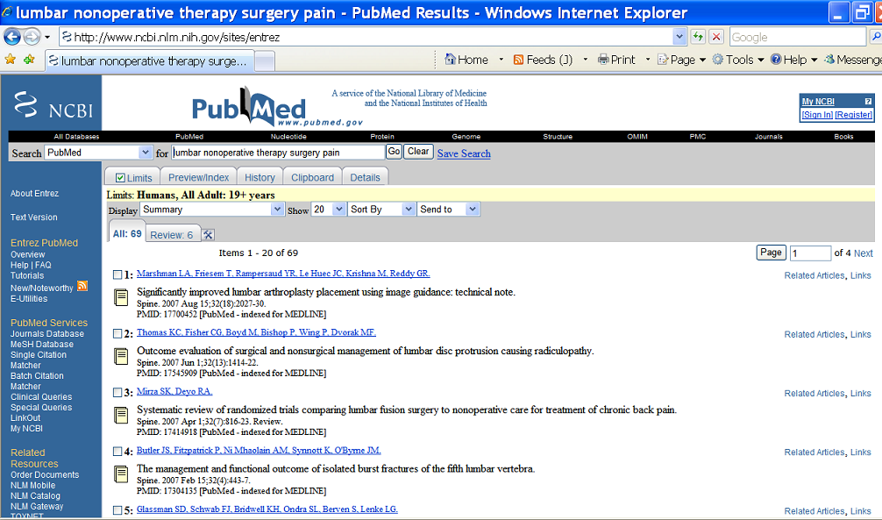
- Viewing Results (fig. 2)
Fig. 2
  - Citations are initially displayed in the Summary view (after step 4 “Click Go.”). The default is 20 per page with the most recently entered citations displayed first. The default can be changed.
  - Browse the results by scrolling. Under 200 results for an initial search is a relatively good result.
  - Enter the number of results (items found) in the Search Strategy Evaluation and Selection Rationale (JTASS) form

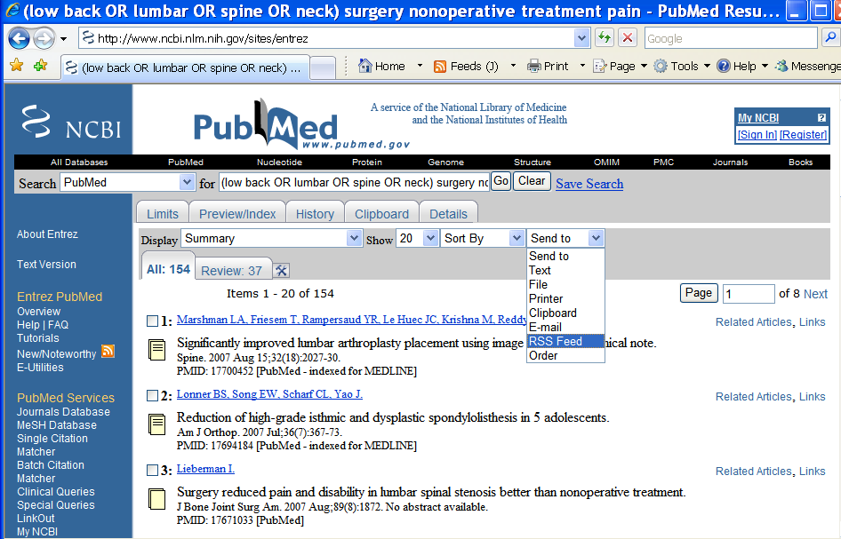
- Managing Search Results (fig. 3)
  - Save the search in “My NCBI” account.
  - E-mail the search results using the “Send to” dropdown menu and the “e-mail” function to
ebp1@nuhs.edu and your e-mail.
    - Type in your name and team # in the box
    - Separate e-mail addresses with a semi-colon (;)
  - Capture the RSS feed for the search
    - RSS (Really Simple Syndication) is a data (XML) -based format used to send new items or information to recipients who use RSS feed readers (available on the Web). PubMed RSS feeds include the latest biomedical articles with links back to PubMed citations.
Fig. 3 The RSS Feed for this search is: http://eutils.ncbi.nlm.nih.gov/entrez/eutils/erss.cgi?rss_guid=0bLEGG5rkEAqDl-I1NaDKuqUfYg9F2z2Jd6XYG5wYhJ
    - The RSS feed can be used as a hyperlink in a Word document to link the reader to an updated automatic search.
    - Click on “Send to” and RSS feed.
    - At the RSS info page, read about the RSS feature.
    - Click on Create Feed button.
    - Select and copy the URL in the browser address bar.
    - Paste the URL into a document (Search Strategy and Evaluation Form). Click on the hyperlink to run the search automatically when desired.
    - Directions are on the RSS feed page.

- Revising Search Results (fig. 4)
  - Browse the search results.
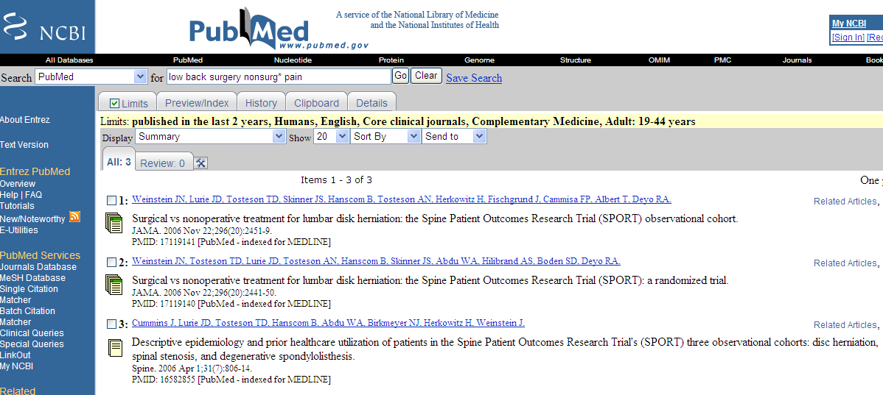
  - Click on the title of an interesting article.
Fig. 6
  - Click on the Display drop down menu. (Fig. 4)

  - Select “Citation” (Fig. 5.)
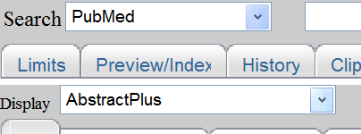
Fig. 4
  - Examine the Citation information to see how this article (and similar articles) are indexed, categorized, catalogued and archived. This view will list alternative key words and MeSH terms. 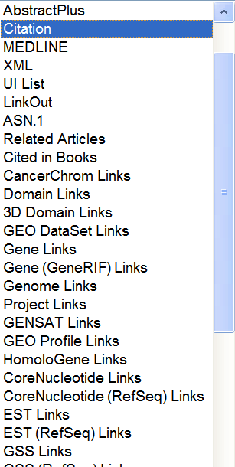
Fig. 5

  - Revise the search by adding limits (Fig 6) using the Limits tab. Note revision on the Strategy Evaluation and Selection Rationale Form
    - Add: published in the last 2 years, Humans, English, Core clinical journals, Complementary Medicine, Adult: 19-44 years
    - Add: “Core Clinical Journals” subset to ensure quality of the journals searched as well as name recognition.
    - Add: “Complementary Medicine Journal” subset to include complementary and alternative medicine (CAM) topics and journals.
  - Note how many items the added limits retrieved on the Search Strategy Evaluation and Selection Rationale Form
    - NOTE: Adding more limits may cut the originally retrieved results too much. This may eliminate too many citations in some cases.
  - Click on Limits again. Un-check the Core clinical journals and CAM journals.
    - Click search.
    - Note the change in results on the Search Strategy Evaluation and Selection Rationale Form

- Access an abstract and citation information to evaluate using JTASS

  - At the search results Summary view, scroll down to the paper by Weinstein JN et al.: Surgical vs nonoperative treatment for lumbar disk herniation: the Spine Patient Outcomes Research Trial (SPORT): a randomized trial. (Fig 7)
 | Weinstein JN, Tosteson TD, Lurie JD, Tosteson AN, Hanscom B, Skinner JS, Abdu WA, Hilibrand AS, Boden SD, Deyo RA. | Related Articles, Links
Surgical vs nonoperative treatment for lumbar disk herniation: the Spine Patient Outcomes Research Trial (SPORT): a randomized trial.
JAMA. 2006 Nov 22;296(20):2441-50.
PMID: 17119140 [PubMed - indexed for MEDLINE]
Fig 7
  - Click on the Author link. (Fig. 8) to go to the AbstractPlus view
.Weinstein JN, Tosteson TD, Lurie JD, Tosteson AN, Hanscom B, Skinner JS, Abdu WA, Hilibrand AS, Boden SD, Deyo RA.

  - At the AbstractPlus view, capture the static (permanent) URL (link) to the abstract. (Fig. 9)
    - Copy the address from the browser bar.
    - Paste the URL into a document (Search Strategy and Evaluation Form).
    - Clicking on the hyperlink in a document will link to the abstract. This allows efficient communication of the abstract to other interested parties and colleagues.
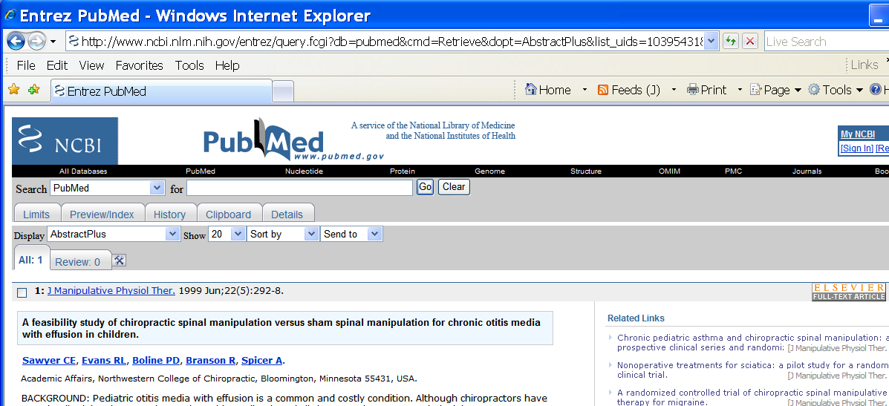
Fig 9

  - Evaluate the Abstract and citation using the JTASS method at the AbstractPlus view. (View automatically changes to the Abstract Plus view – the abstract and citation -- when the authors link (Fig.8) is clicked in the results summary view.)
    - Note that the Citation view (use the Display drop down box and select “Citation”) has database links that will supply JTASS information as well. The Citation view also contains links to MeSH terms, publication type and other data fields.

- Evaluating a Citation using JTASS

  - Click on the Journal name link to find information about the Journal in which the paper was published.
    - Click on the “Journal” link in the pop-up box.
    - Note the publishing information and history.
    - Click on the NLM ID (National Library of Medicine ID) to see where the journal is indexed, if it is peer reviewed, indexed in Mediline and other Indices or Databases, etc.
    - Answer the questions under “Journal” in the JTASS Guide to evaluate the authority and quality of the journal on the Search Strategy Evaluation and Selection Rationale form.
  - Click on Author links (2) to see the publishing history of the authors.
  - Note the site where the authors work and if there is any vested interest or bias regarding the study outcomes or results.
  - Note that the “first author” e-mail is often available on this page. Contacting the author is one way to obtain the full text as well as related information and evidence.
  - Summary or Abstract content: assess the content of the abstract carefully using the JTASS Guide. Do key words match the key words of your PICO (relevant)? Is / are the patent(s) or population similar to yours? Is the intervention something within your scope of practice or interest? Are the outcomes (what you want to accomplish) clinically relevant, important to you and your patient? Is the research question or hypothesis apparent? Is it what you wan to know? Summarize the abstract relevance. Do not copy and paste the abstract into the JTASS form.
  - If the JTASS evaluation indicates the article is high quality, authoritative, relevant and applicable, access the full text using the direct publisher’s link (6). Some JAMA articles will require using the NUHS LRC password and ID at the publisher’s page. (See Resources for Password list.)

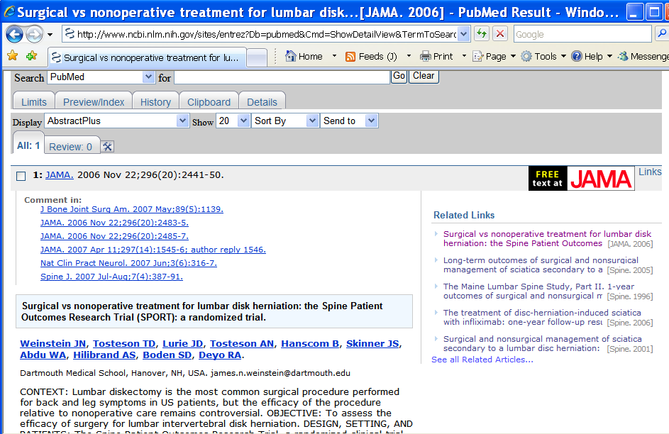
Clicking on the title at the results Summary view leads to the Abstract Plus view
1. Journal link
2. Author links
3.Site of authors vs. site of study (see abstract).
5. “Summary” Abstract
6. Access the full text
4. Author contact (e-mail)

Search Strategy Evaluation and Selection Rationale
Perform a Search using both PubMed and EBSCOhost.
You may start with search engines and compiled evidence websites if you want to focus your questions or find background information or database management systems and databases of the biomedical literature.
PICO Question:
Type your PICO format clinical question here.

Search Engine(s) / Database Management System(s) used / Database(s) Searched:
❑ Search engine / website ___________________________
- Database management system / Database ______________________________
❑ Entrez Pub Med / PubMed
❑ EBSCOhost
❑ Note others
Key Search Terms (number the revisions)

Limiters Used & Special Techniques Used (Note limits and filters used such as Human, Journal type, Explode function, peer- review, dates, etc. as well as Truncation, Near, Within, Wildcard, etc)

Full Query (Copy and paste the query here - example: ((knee AND hip AND pain)) and DE "Female")

Search Results (How many results total and estimate the % relevant based on the first page of results)

RSS link to search (Copy and paste the RSS link for the search from the database RSS feature )

Selection Rationale (JTASS)
JTASS stands for: Journal, Title, Author(s), Site, and Summary
Use the guide questions at the end to summarize your selection rationale.

Bibliographic Citation (citation) using Vancouver style format:

Example: Rowell R, Lawrence D, Hawk C. Relief of depressive symptoms in an elderly patient with low back pain. Clinical Chiropractic 2006 May; 9(1): 34-38.

Static link (Copy and paste the static link of the article abstract from the PubMed Abstract Plus view or the EBSCOhost title at the search results view)

Selection rationale (why did you choose the paper):
Journal

Title

Author

Site

Summary (Key relevant aspects of the abstract)

JTASS Guided Questions
JTASS: Journal, Title, Author(s), Site and "Summary"
Answer the following questions to determine the quality, relevance, and applicability of an article. Do not cut and paste or copy text directly from the abstract or article.
NOTE: "Summary" in this context is synonymous with "Abstract"
Journal Understand and appraise the quality of the journal.
Are you familiar with this journal?
Is it peer-reviewed? Is it indexed? If indexed, where is it indexed? (Note where and how you obtained information about the journal)
(Why is it important that journal articles be peer-reviewed and indexed?)
Note other quality characteristics of the journal: publishing history, professional affiliation, availability, etc.
Title Evaluate the title and determine relevance to your patient question .
What are the key works that attracted your interest? How much information is available in the title alone?
What key words are relevant to your clinical question (PICO)?
Is this study potentially interesting or possibly useful in your clinical practice? Why (or why not?)
Author(s) Determine the experience & expertise of the authors.
Is the track record of the authors one of careful, thoughtful work that has stood the test of time?
What areas of expertise do the authors bring to this study? Is there any
indication that methodologic and/or statistical expertise was utilized for this
study?
Site Compare the site where the study was performed to your practice.
Where is the site where the study was performed?
Is the site considered primary (a private practice office), secondary (a medical center clinic or consulting health professionals), or tertiary care (specialty care)?
Is the site sufficiently similar to your own practice location so that results, if valid, would apply to patients in your practice?
Is your access to the required facilities, expertise and technology
sufficient to allow you to implement the maneuver(s) therapy or tests described in the article?
Are the patients seen in the facility where the article was written likely to be similar to your patients in disease severity, treatment, age, sex, race or other key features that have an important bearing on clinical outcomes?
In areas where the site is not similar, what are the potential consequences as to how you will read the results?
Summary From the abstract body, determine which, if any, of the outcome measures, results and other aspects in the abstract are clinically important to you and applicable to your patient. State why.
Succinctly synthesize and summarize the key characteristics that are relevant to your clinical question (PICO), your patient and your practice.
Do not cut and paste or copy text from the abstract.

